Concord Seed Lending Library
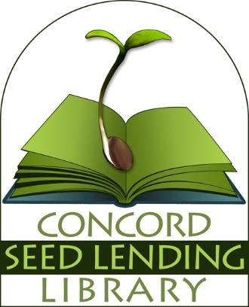

Resource List:

- Seed Libraries:
- Concord Seed Lending Library www.concordseedlendinglibrary.org
- Richmond Grows Seed Lending Library
www.richmondgrowsseeds.org
- Groton Public Library Seed Bank
www.gpl.org/what-we-have/seed-library/
- Seed Library Littleton
www.littletoncommunityfarm.com/seed-library-littleton/
- Bay Area Seed Interchange Library
www.basilseedlibrary.com/
- The Seed Library Social Network
www.seedlibraries.org/

- Seed Saving Web Sites:
- Seed Savers Exchange
www.seedsavers.org/
- Vegetable Seed Saving Handbook
www.howtosaveseeds.com/
- International Seed Saving Institute
www.seedsave.org/issi/issi_904.html
- NW Farms & Food
www.nwfarmsandfood.com/index.php/how-to-screen-and-winnow-seeds
- Seed Ambassadors
www.seedambassadors.org/docs/seedzine4handout.pdf
- Fedco Seeds
www.fedcoseeds.com/forms/seedschool.pdf
- Organic Seed Alliance
www.seedalliance.org/
- Seed Matters
www.seedmatters.org/

- Seed Saving Books:
- Seed to Seed: Seed Saving and Growing Techniques for Vegetable Gardeners by Suzanne Ashworth (this is the bible)
- Organic Seed Production and Saving: The Wisdom of Plant Heritage by Bryan Connolly (another bible)
- The Complete Guide to Saving Seeds: 322 Vegetables, Herbs, Fruits, Flowers, Trees, and Shrubs by Robert E. Gough and Cheryl Moore-Gough
- Seed Saving for the Organic Gardener by Martin Anderson
- Saving Seeds: The Gardener’s Guide to Growing and Storing Vegetable and Flower Seeds by Marc Rogers and Polly Alexander
- Seed Sowing and Saving: Step-by-Step Techniques for Collecting and Growing more than 100 Vegetables, Flowers, and Herbs by Carol Turner

